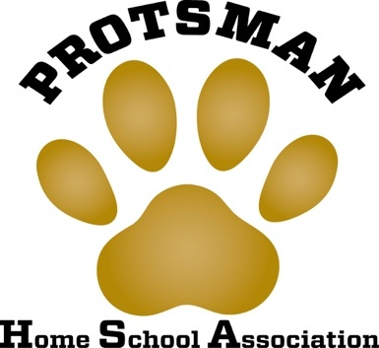
HSA Meeting Minutes
Wednesday, November 27th, 2018

- Call to Order and Pledge of Allegiance – 3:06 p.m.

- Secretary’s Report
  - Danielle Churilla went over minutes from October 2018.

- Treasurer’s Report
  - Lindsay Musch recapped the profits & expenses to date.

- Old Business
  - Fall Family Fun Night was a great success! Almost 1,000 people in attendance. Thanks to teachers, staff, parents, and students!

- New Business
  - Scrips Fundraiser – Gift cards will go home with students the week of December 3rd.
  - Box Tops – Closed out for 2018. May collection was $288; October collection was $704.40. Grade level winners: K – Popa, 1st – Venturelli, 2nd – McCarter, 3rd – Jernberg, 4th – Kucharski. Each class will get an ice cream party. Next round will be in February. $44,018.62 has been earned to date.
  - Holiday Shop – New this year! Will be held in the Library during Library time the week of December 3rd.
  - Fun Fair – first planning meeting will be in December, date TBD.
  - Recognized the Spell Bowl team, who finished 2nd in their division at the local competition, and top 10 in the state. Students received a certificate and a DQ gift card.

- Principal’s Report
  - Kudos to Spell Bowl teachers, students, and parents!
  - Winter Concert, featuring Choir and Recorder Club, will be 12/18, at 6:30pm.
  - Classroom holiday parties will take place on 12/20
  - Friday, 12/21, is the last day before the holiday and the last day of the grading period. Report cards will be available on 1/9.
  - Teachers report back on 1/17 and students on 1/18. On 1/17 teachers will be prepping for i-Read and participating in professional development.
  - Before school tutoring ends on 12/19 and starts again on 1/29.

- PTF Drawing Winners
  - Bendis, Finnegan, Galosich, Sarkey

- Next Meeting – Wednesday, January 23rd at 3:00 p.m.

- Adjourned at 3:22 p.m.

